It’s still not to late to do your swim trials!

How to calculate CSS?

CSS (m/sec) = (400 - 200) / (T400 - T200)
Where T400 and T200 are your 400 and 200m times in seconds.
Or you could visit this website:
http://www.swimsmooth.com/training.html#ixzz4ZiMKh4FJ

OR

1. Get FREE App CSS calculator

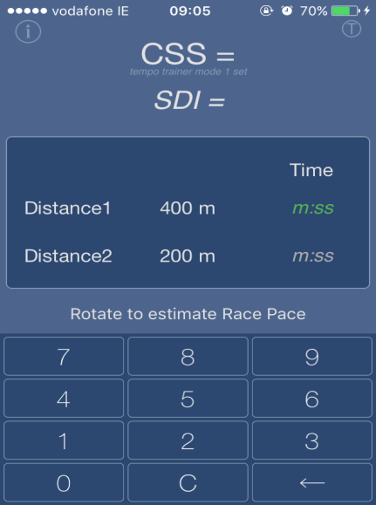

2.Enter your times to calculate CSS, example below

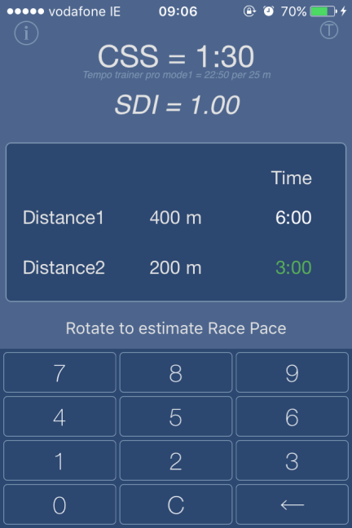

3. In the left corner you can find “i” letter which explain how to perform the test (if you haven’t done it yet)
And in the right corner you find “T” letter which calculate swims above and below CSS per 25 or 50m. In this case you would need TEMPO TRAINER which I’ll talk about it next week.

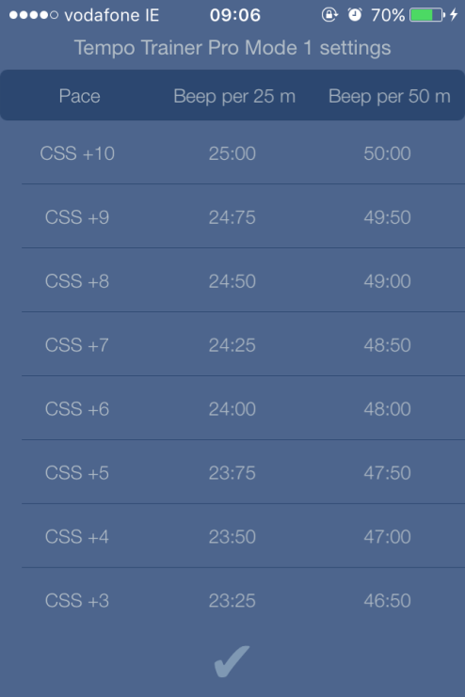
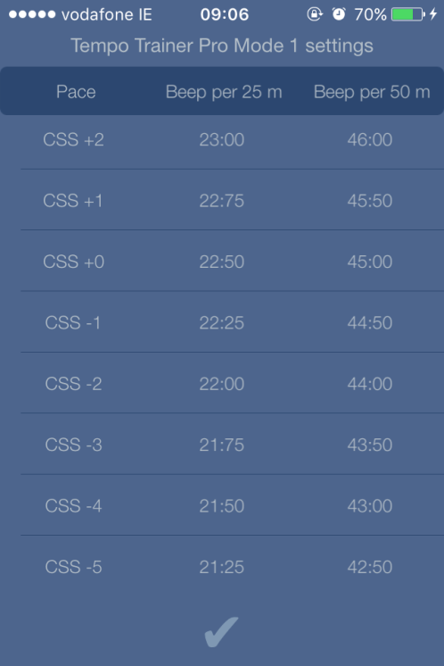
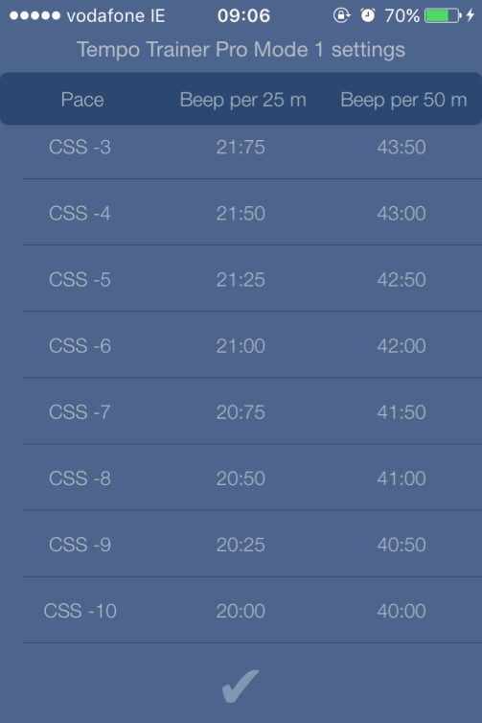

Convert your speed from m/sec into time for distances below.
Distance | 50 | 100 | 150 | 200 | 300 | 400 | 500 | 600 | 700
Time

Distance | 800 | 1000 | 1500 | 1900 | 3800
time

