Mini Triathlon – Piranha TC

Date: Sunday 26th April

Time: 09:00 Sharp

Transition: Open 8am Closes 8:45 pm

___________________________________________________________

Swim: 400 Meters
Rules:
Be on deck 8:50
Warm up until 8:55
Female Start: 9 am Male Start: 9:10

Swim Clockwise

Touch Wall move to next lane

Remember position gives advantage

On completion of Swim, exit pool through emergency exit, (you will need runners to get to T1)

Start: Exit
Transition (T1 / T2 )
Enter transition at In and Exit on footpath (Out)

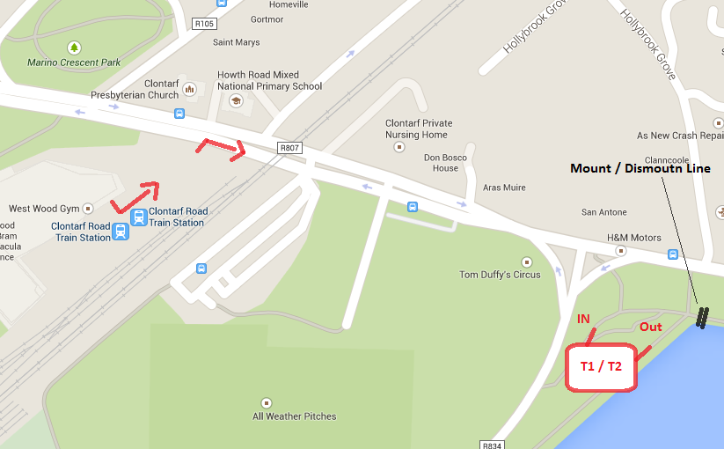

Bike 10.8 KM ( Out to Wooden Bridge and Back x 2 )

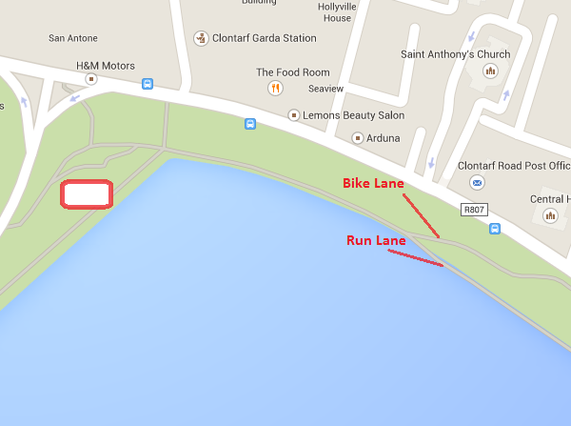

RUN 5 Km

After dropping your Bike in T1 progress to the run. Enter Transition at (IN) and Exit again at (Out)
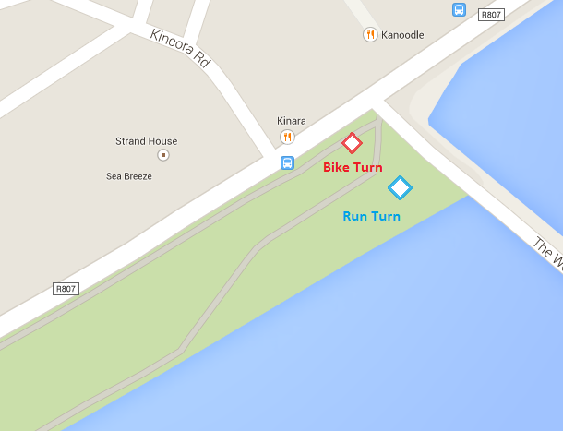

Marshals Required at
- Pool (2)
- Traffic Lights (2)
- Transition (2)
- Half way Point (1)
- Turn Point (1)

I would estimate a minimum of 6-8 Marshals / Volunteers.

