Step 1. Access your profile details via main site Forum> register
This will bring you to the Register screen
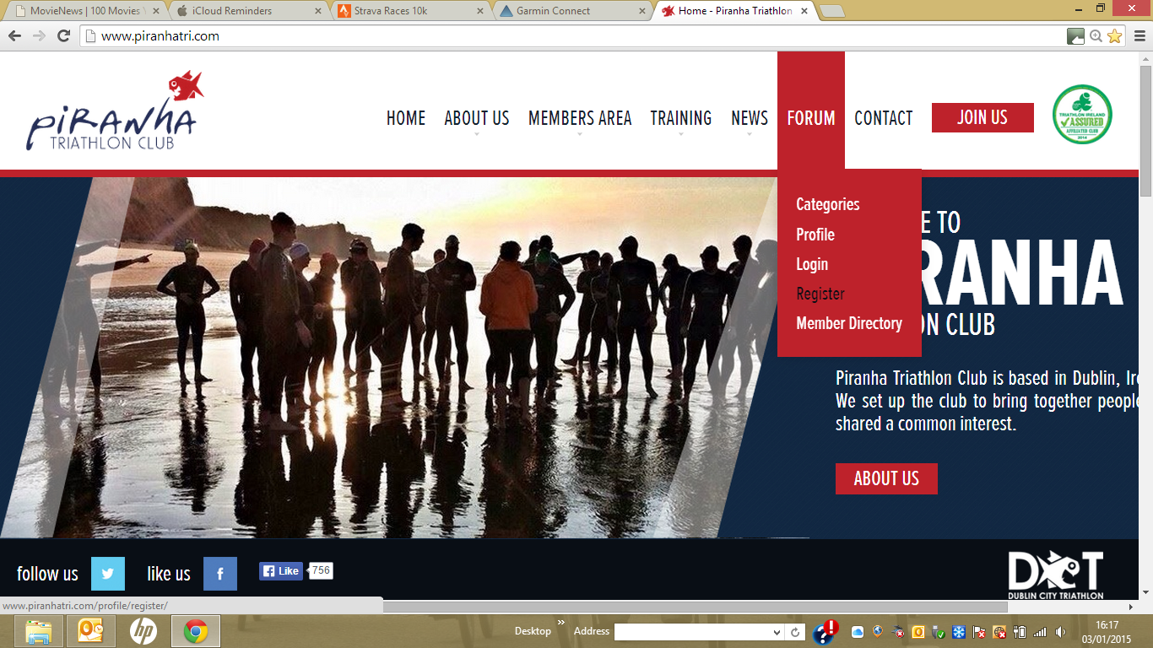

Step 2. Enter the following fields
User name – NB make this something that will help identify you i.e. use your name if you can
Email address – this will be where notifications will be sent to so best use the email address you check regularly
Password – NB use a combination of letters and numbers to make it hard to guess
Answer the anti spam question – this should be a numeric answer ie “5 + 2” will be 7
Also complete the Profile details information and ensure you add a user name that helps identify you (NB being able to identify yourself from this name will speed up the approval of your profile)
Also add a picture – as this will help your club mates when they try to meet you for your first run/bike/swim sessions
When done – click on register to complete the process

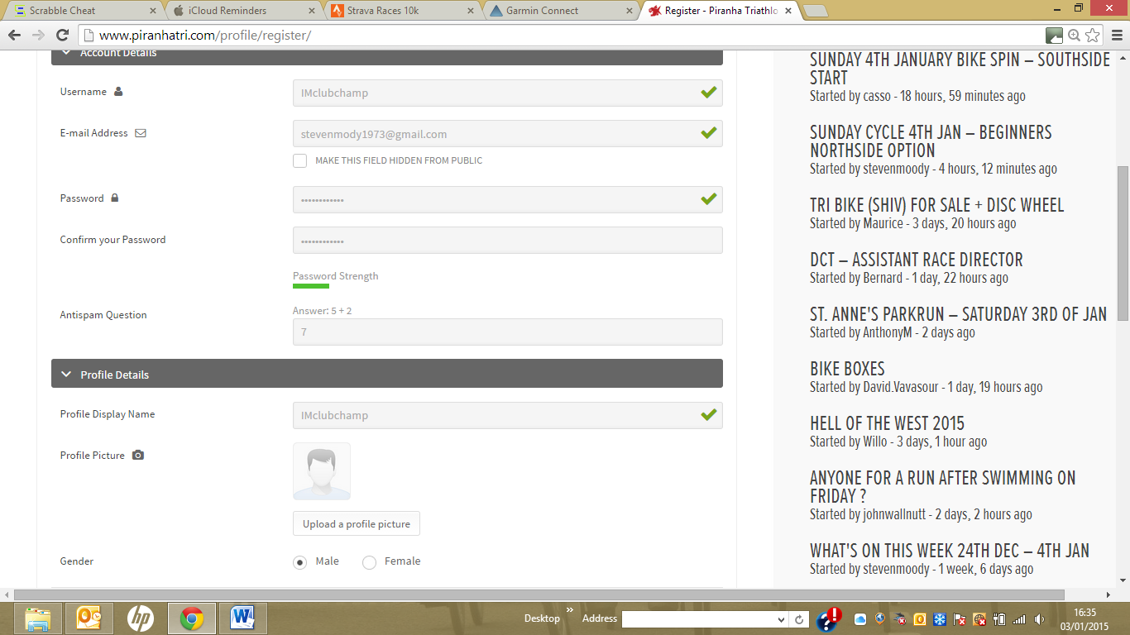

If successful you will see the following confirmation message,
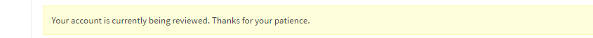
This means your profile is being reviewed to confirm you have paid your subscription fees and if so, you will be approved and receive an email notification saying you are able to log in.

